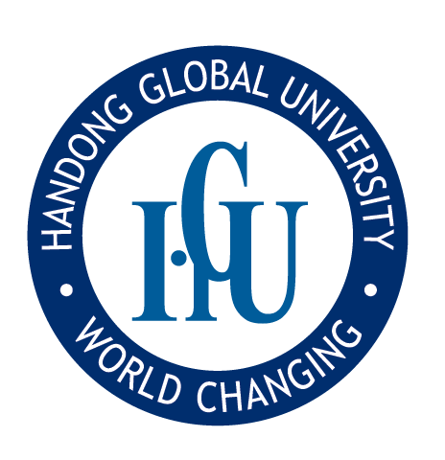
Handong Global University,
Announcement of Full-time non-tenure-track Faculty at Chaplain’s Office Opening,
Fall Semester of 2026
Handong is God’s Institution- Educating People of God through Ways of God
We Invite Faculty of Handong
Handong Global University is a community that nurtures individuals who practice truth and love based on Christian values and seek to transform the world with the values of the Kingdom of God. Accordingly, we invite professors who resonate with the university’s educational philosophy and mission, and who possess both academic excellence and a strong spiritual calling.
“Therefore, holy brothers and sisters, who share in the heavenly calling, fix your thoughts on Jesus, whom we acknowledge as our apostle and high priest.” (Hebrews 3:1)

1. Departments and Fields
Status | Department | Major | Field | Position | Opening
Full-Time Non-Tenure Track Faculty | Chaplain's Office | Pastoral Ministry | General Theology | Invited Professor | 1

2. Qualifications
Applicants may apply if they meet the qualifications below and can view their major from a Christian perspective, guide students, and understand the holistic educational policy of the institution as well as the evangelical Christian spirit, and participate in its implementation.
- Qualifications and Preferred Qualifications by Each Department (fields)
Department | Qualifications and Preferences by Each Department
Chaplain's Office | [Qualifications]  - Holders of a Master of Divinity (M.Div.) or Master of Theology (Th.M) or higher  - Research publications are not required for candidates with 3 years or more of experience in the relevant field  - Submission of written sermons and sermon videos  [Preferred Qualifications]  - Able to teach and preach in English  - Ordained pastor with at least 3 years of pastoral experience  - Experienced in a Christian university chaplaincy  - At least 3 years of experience in overseas missions or domestic missions to foreigners

- Common Qualifications for Full-Time Faculty Application and Preferences

Category |  | Content
Qualification for Application | Qualification | • A person who has no grounds for disqualification from the appointment of a private school faculty under Article 54-3 of 「Private School Act」  • Followed by the qualifications of [Regulation on Qualification Criteria of University Faculty Member]
C. Research Performance Evaluation Criteria
◦ The evaluation criteria for research performance are as follows:
- 100% for journals listed by the National Research Foundation of Korea, 100% for doctoral dissertations, 200% for international journals (SCI, SSCI, SCIE, AHCI, SCOPUS)
- Research Performance Recognition Conversion Rate: 100% for solo research, 70% for two, 50% for three, and 30% for four or more.
Note: For research outputs and qualifications, if there are specific requirements provided by the department (field), those will be followed.

3. Application Method and Required Documents
- Application Period: April 20, 2026 (Monday) to May 4, 2026 (Monday) by 11:00 [Korean Standard Time]
- Application Method: Submit by email with a PDF file of the following documents (facultyrecruit@handong.edu)
Please submit files in the format "Name_Filename".
Example)
1. Name_Faculty Application.pdf
2. Name_Certificate of Degree.pdf
3. Name_Certificate of Work Experience.pdf
- You can download a link to the application by following the link below;
Handong Global University(http://www.handong.edu)
D. Required Documents
1) One copy of faculty application
2) Proof of education (previous education) and career experience
※ If the submitted documents do not confirm your eligibility, you may submit additional documents.
3) Proof of theses, research achievements, and career experience, etc.
4) Two letters of recommendation – one from a major-related recommender and one from a non-major(faith) related recommender.
5) Sermon Text and Sermon Video (File or Link)
※ If sending as a file, video files can be sent via email if the file size is large.
E. Review Process : Qualification Review ⇨ Integrated Review(Basic & Major Review) ⇨ Interview Review ⇨ President's Interview
Note: Each stage is conducted only for those who pass the previous stage, and results at each stage will be notified via email.
          - Evaluation of suitability in the major area, academic excellence, and teaching ability.
          - Assessment of understanding of the school, university vision, global competencies, and ability to teach in English.

F. Appointment Date: September 1, 2026
※ Schedule subject to change depending on circumstances
※ Applicants must submit original documents and supporting documentation for background checks.

4. Others
- Applicants holding a bachelor's degree from a specific university may be restricted from employment (Reference Regulation: Article 4-3 of the Education Public Officials Employment Act).
- If there are no qualified candidates, we may not invite you.
- If there are discrepancies between the application content and the information provided after acceptance, the acceptance will be revoked.
- Other matters not specified in this announcement will be governed by the regulations related to faculty personnel as outlined in the bylaws of Handong Global University.

5. Inquiries
For further details, please contact the Office of Academic Affairs
Person in Charge: facultyrecruit@handong.edu
Website: http://www.handong.edu
Tel. 054-260-1076 / Fax. 054-260-1079

